21 February 2009

Erotosthenes Project - Method 4 (Werner Schmidt Observatory)

For those of us who wish to confine the measurement of the Earth diameter to actions within the boundaries of Cape Cod, this method has the potential to give almost an order of magnitude more accuracy than other methods. The key advantage is that the method is relatively immune to error due to atmospheric refraction.

Measuring the parallax offset of stars relative to the Moon is only affected by the slight difference in refraction over a small angle. The major source of error when taking these measurements is the granularity of the CCD chip used with the Werner Schmidt Observatory (WSO) telescope.

Theory of the approach:

Short version:

Examine the parallax of stars near the Moon due to the combination of the Earth orbital motion and the Earth rotation. Null out the effects of Earth orbital motion. Extrapolate the parallax angular motion of stars due to the rotation of the Earth during transit of Moon as would be seen by an observer on the Earth equator.

Measure a base line on the Cape. Determine the difference parallax angle of a star as seen from each end of that base line. Use the base line length and the parallax of a star to calculate the distance of the Moon. Use the distance to the Moon and angular motion at equator to determine velocity at equator. Sum the velocity for 24 hours to determine circumference of Earth. Divide by pi to determine the Earth diameter.
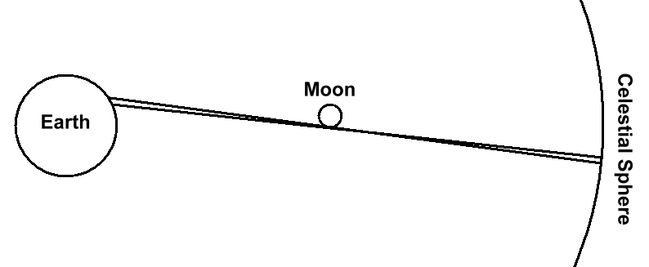
Picture 1 – Parallax distance to Moon – Not to scale

Long version:

We know the orbit of the Moon around the Earth to a reasonable degree of accuracy. The semi-major axis of the Moon’s orbit is 238,866 mi and the eccentricity is only 0.05490.

The Moon appears to move in front of the celestial sphere (as it would be seen from the Earth center) at almost constant angular velocity and distance relative to the Earth center. This ranges from about 28 to 40 seconds of arc per hour but changes less than ½ second of arc per hour during any 3-hour period. What is more important is that the acceleration in that change is very small. That is to say, if we average the angular rate of change 3 hours before and 3 hours after the Moon transit time we will come very close to the angular rate of change for the Moon transit time.

(V_{Ao} + V_{Co}) / 2 = V_{Bo} (almost) (1)

where:
V_{Ao} = Orbital velocity before transit by delta time
V_{Bo} = Orbital velocity at transit time
V_{Co} = Orbital velocity after transit by delta time

We will refer to the apparent motion of stars relative to the Moon as parallax angular velocity. The expression (1) above only relates to the parallax angular velocity due to the orbit of the Moon around the center of the Earth.

An observer will see an additional component of parallax angular velocity due to the rotation of the Earth. This component of parallax angular velocity is a maximum when the Moon crosses its transit position over the observer. At that time, the observer is moving perpendicular to the line of sight to the moon. At all other times, the angular velocity due to the rotation of the Earth will be less.

In order to measure the diameter of the Earth, we measure the parallax angular velocity at three equally spaced times, the middle of which coincides with the transit of the Moon. The exact time spacing of these measurements will depend on star locations, Moon phase, Sun rise, and Sun set. Hopefully the spacing will be close to 3 hours each.
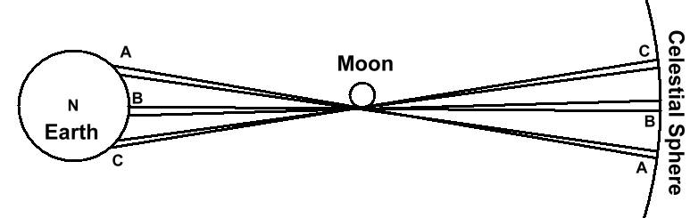
Picture 2 Three test points – top view – Not to scale
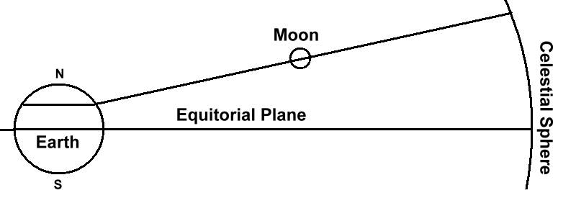
Picture 2 – Three test points – side view – Not to scale

We measure a parallax angular velocity by observing the parallax of stars relative to the Moon on CCD images. That is to say, capture start and end CCD images of a star and the moon separated by a known time. Using the Moon as the frame of reference, measure the distance between the star in separate images. Scale that distance by the number of degrees per pixel and divide by the time difference between start and end.

AV_{n} = sqrt((Xn₂–Xn₁)*(Xn₂–Xn₁) + (Yn₂–Yn₁)*(Yn₂–Yn₁)) * Scale / dt (2)

where
AV_{n} = angular velocity from a pair of images (n = A, B, or C)
X₁ = horizontal position of 1st point relative to the Moon
X₂ = horizontal position of 2nd point relative to the Moon
Y₁ = vertical position of 1st point relative to the Moon
Y₂ = vertical position of 2nd point relative to the Moon
Scale = number of degrees per pixel (see calibration below)
dt = time between 1st point and 2nd point measurements

In practice we make use of equation (1) and (2) to find AV by the alternate method:

AV = AV_{B} - ( AV_{A} + AV_{C} ) / 2 (3)

What is important is that in the above expression (3), the rate due to the orbital motion will cancel out and what we are left with is the observed difference in angular velocity due to the rotation of the earth, AV.

If the Moon were in the same plane that the observer is rotating (i.e. – the plane of the observer parallel to the equatorial plane), the parallax angular velocity due to the rotation of the Earth varies as the cosine of the hour angle relative to the point on the Earth directly under the transit meridian.

Initial examination of the Luna orbit shows that it can be above or below the equatorial plane by as much as 23 degrees. That could increase the observed angular velocity before and after the transit by more than 5 % and must be accounted for.

Note that our location not being on the equator only adds about 1/3 of a degree to that value and may be considered insignificant.

The expressions to extract parallax angular velocity due to Earth rotation is:

F_{X} = cos( delta * 360 / 24 ) (4)
F_{Y} = sin( delta * 360 / 24 ) * sin(Dec) (5)
Factor = 1 / (1 - sqrt( F_{X} * F_{X} + F_{Y} * F_{Y} )) (6)

where:
F_{X} = factor for motion perpendicular to line between observer and Moon
F_{Y} = factor for motion parallel to line between observer and Moon
delta = time before and after transit of measurements A and C respectively
Dec = apparent declination of the Moon
Factor = expansion factor to determine velocity at observers latitude

We use the equation for an isosceles triangle to measure the current distance to the Moon.
We can measure a base line (of the triangle) from the WSO to Race Point Beach using an automobile and compass. The measurement is done in many segments doing a vector sum of all the segments. That measurement can be done days in advance.

The distance to the Moon does not change more than 0.1% during any 3-hour period. We measure the angle at the apex of the triangle by again observing the parallax of a star on a CCD image at the WSO just as the other end of the base line (at Race Point Beach) sees the star blink out behind the Moon. That measurement can be done any time during the data acquisition period (6 hours).

h = (base / 2) / tan(angle / 2) (7)

where
h = height of the moon above the Earth surface in miles
base = distance between Observatory and Race Point Beach in miles
angle = angular distance of test star from the Moon in the CCD image

We calculated a fraction of parallax angular velocity due to the rotation of the Earth in expression (3) and the Factor to translate that to the full parallax angular velocity due to the rotation of the Earth in expression (6). Again applying the isosceles triangle equation and the known distance to the Moon, we convert from angle to velocity of the observer. From that we can divide by cos(latitude) to find out the velocity at the equator.

V = Factor * (2 * h / tan(AV / 2)) / cos(latitude) (8)

where:
V = velocity in miles per hour
Factor = factor derived by equations (2), (3), and (4)

We then find that the circumference is:

Circumference = 24 * V (9)

and the diameter of the Earth is:

Diameter = 24 * V / Pi (10)

where:
Diameter = diameter of the Earth in miles
V = velocity in miles per hour
Pi = the constant 3.1415926…

Calibration:

While we make use of electronic star charts and the like to plan our experiment, all measurements except star positions and star separations must be made using available tools.

1. Telescope – CCD image:
The most critical calibration is that of the CCD image. Our accuracy of our measurement of the Earth diameter will vary directly as the accuracy of the value of Scale in equation (2). Published specifications are not to be trusted in this area.

For example, back in April of 2005 I received an e-mail from Jim Carlson which stated, “I have a program which purportedly calculates the fov for the camera/telescope/f ratio combination. It says that the fov for a 16-inch telescope at f/6.3 with an ST8XE whose chip size is 9.2mm x 13.8mm with an array of 1530 x 1020 pixels, is 12.5 x 18.8 arc minutes.” That implies a Scale factor of 0.737 arc seconds per pixel. But the picture he sent me proved to be 24.6 x 16.0 arc minutes (by comparison with star charts). That implies a Scale factor of 0.965 arc seconds per pixel.

Calibrate by taking an image of a known portion of the sky above 45 degrees altitude with two known star positions at least 20 arc minutes apart. Apply equation (11) below to generate the value of Scale for use in equation (2) above.

Scale = sqrt((X₂–X₁)*(X₂–X₁) + (Y₂–Y₁)*(Y₂–Y₁)) / dx (11)

where
Scale = number of degrees per pixel
X₁ = horizontal pixel position of 1st star
X₂ = horizontal pixel position of 2nd star
Y₁ = vertical pixel position of 1st star
Y₂ = vertical pixel position of 2nd star
dx = known angular distance between two points

2. Automobile Odometer
Of equal importance is the calibration of the automobile odometer. I know from past measurements that both my Buick Centuries have their odometer readings skewed by about 3% (probably because it shows a higher gas mileage, reduces the warrantee exposure, makes the car devalue faster). Our accuracy of our measurement of the Earth diameter will vary directly as the accuracy of the odometer accuracy.

Calibrate the odometer by driving slowly on a straight piece of road and droping loose sand bags (non-bouncing) at two 1/10th mile clicks. Then get out and measure the distance between bags (should be 528 feet) with a tape measure. The base line measurement will be multiplied by:

Distance_calibration = measured_distance / 528 (12)

3. Compass deviation
The compass deviation is not as critical as the previous two calibrations. An error of 8 degrees in deviation will only cause a 1 % error in the calculation of the diameter of the Earth. However, if the compass readings are not linear, that could produce a significant error.

Calibration is done by choosing a straight stretch of road in an almost northerly direction, measure its azimuth with the portable telescope after aligning the telescope to the North Star, checking the compass reading in the car lined up with the road, and apply the following equation (13).

Magnetic_deviation = Compass_reading – Road_azimuth (13)

We will also do a sensibility check of the measured baseline with Google Earth, but unless there is a major problem, we will accept the measured base line.

4. Latitude
Fortunately, the latitude is also not as critical as the first two calibrations. An error of 52 minutes of latitude will result in about a 1% error in the diameter of the Earth.

Some GOTO telescopes do not require input of latitude and longitude or time to align on the celestial sphere. However, the WSO telescope does and it is not clear that the value of latitude is modified by the telescope is alignment. It is also not clear if the telescope uses the latitude and longitude in it’s calculation of altitude and azimuth. Therefore, we will do an independent measurement of the Latitude for the purpose of the measurement of the Earth diameter.

Calibration of the latitude is performed with the portable telescope by measuring the height of the North Star over an ocean horizon.

5. Declination of the Moon
The declination of the Moon is taken directly from the WSO telescope. Once aligned to the celestial sphere, the telescope will read out the declination of the Moon if we point the telescope at the Moon.

Other Considerations

The accuracy is very dependent on the granularity of our measurement. In equation (3) we will find that AV is about 1/8 the size of AV_{A} , AV_{B} , or AV_{C} . That said, the parallax angular difference from start to finish of any measurement needs to be in the order of 800 pixels to result in a granularity of measurement of about 1%. With the CCD being 1530 x 1020 pixels, and the fact that we need to capture enough Moon to register our framework in both lateral position and rotation, it becomes clear that, even if we are extremely accurate in all our measurements, we will not do much better than 1% accuracy. With interpolation techniques on the data, we might do twice that good.

